Smart-Camp Box: An Integrated IoT and Artificial Intelligence Framework for Safety, Communication, Learning Assistance, and Resource Optimization in Disaster Relief Camps

Kashmira S S
Faculty of Computing
Sri Lanka Institute of Information Technology
Malabe, Sri Lanka
IT22059772@my.sliit.lk

Prof. Anuradha Jayakody
Head | Department of Computer Systems Engineering
Faculty of Computing
Sri Lanka Institute of Information Technology
Malabe, Sri Lanka
anuradha.j@sliit.lk
Hansana G P
Faculty of Computing
Sri Lanka Institute of Information Technology
Malabe, Sri Lanka
IT22064868@my.sliit.lk
Ms. Shashika Lokuliyana
Computer Systems and Network Engineering Program Coordinator / Senior Lecturer
Faculty of Computing
Sri Lanka Institute of Information Technology
Malabe, Sri Lanka
shashika.l@sliit.lk

Deerasinghe A D S N S
Faculty of Computing
Sri Lanka Institute of Information Technology
Malabe, Sri Lanka
IT22065780@my.sliit.lk

Abstract - Natural disasters continue to inflict devastating consequences on communities across South Asia, with Sri Lanka ranking among the most frequently affected nations in the region. When disasters strike, temporary relief camps serve as critical shelters for displaced populations; however, existing systems fail to address three persistent operational challenges simultaneously: camp-level flood and landslide prediction, psychological and attentional readiness assessment for displaced children, and resilient communication under degraded network conditions. This paper presents the Smart Camp Box, an integrated, portable IoT-based framework that addresses all three dimensions through tightly coupled sub-systems. The first sub-system provides location-aware environmental risk monitoring using GPS/GNSS, IoT sensors, DEM integration, and a machine learning prediction model. The second introduces the Psycho-Attentional Gated Educational System (PAGES), an offline-first application for assessing and supporting displaced children's cognitive readiness. The third proposes a Semantic-Aware Adaptive Message Prioritization (SAAMP) framework for reliable MQTT communication under constrained network environments. Currently in active development, the Smart Camp Box represents a paradigm shift toward proactive, unified crisis management for relief camp operations.
Keywords—IoT; disaster management; flood prediction; psycho-attentional gating; MQTT; biometric identification; edge computing; machine learning; crisis management; relief camp

Introduction
Natural disasters such as floods, landslides, and cyclones remain among the most destructive forces affecting monsoon-dependent nations in South Asia. Sri Lanka, in particular, experiences recurrent disaster events that displace tens of thousands of families annually. In the aftermath of such events, government authorities activate pre-designated locations as temporary relief camps to provide immediate shelter and humanitarian assistance to affected populations. While these camps represent a critical component of the national disaster response infrastructure, they are not immune to secondary hazards. Prolonged and continuous rainfall following an initial flood or landslide event can threaten the safety of camps located in topographically vulnerable areas, yet most existing monitoring systems provide only regional-level warnings without evaluating whether a specific camp location will be directly affected.
Beyond physical safety, the psychological and educational needs of displaced children represent an equally critical but systematically neglected dimension of disaster response. Traumatic displacement is known to induce neurological suppression that significantly impairs children's capacity for learning and academic engagement [1]. The devastation caused by Cyclone Ditwah in November 2025 starkly illustrated this reality: 890,000 children were affected, 1,682 schools sustained damage, and teacher-to-student ratios reached as high as 1:77, with no AI-driven educational system deployed as part of the emergency response [2]. Conventional educational delivery systems assume psychological preparedness on the part of the learner, a condition that cannot be assumed in post-disaster environments.
Compounding these challenges is the operational reality of disaster environments: communication infrastructure is frequently degraded or entirely disrupted. Existing IoT-based disaster management systems critically depend on stable Internet connectivity and apply uniform Quality of Service (QoS) configurations across all transmitted data, creating severe risks of critical message loss precisely when reliable communication matters most [3]. The failure to distinguish between life-critical biometric registration data and routine telemetry in resource-constrained communication environments can directly compromise human safety and effective camp administration.
This paper presents the Smart Camp Box, a portable, integrated IoT-based framework designed to address all three of these interrelated challenges within a single, cohesive system. The framework comprises three tightly coupled sub-systems: (1) a location-aware environmental risk monitoring and prediction engine, (2) a Psycho-Attentional Gated Educational System (PAGES) for displaced children, and (3) a Semantic-Aware Adaptive Message Prioritization (SAAMP) framework for resilient MQTT-based communication. The remainder of this paper describes the motivation and background for each component, the proposed methodology, the current state of development, and the expected contributions of this work-in-progress to the field of crisis management technology.
The following are some related works that can be found.
- Environmental Risk Monitoring Systems
A substantial body of research has focused on developing IoT-based flood monitoring and early warning systems. Krishnamurti et al. demonstrated the potential of sensor network deployments for real-time flood detection, while Islam et al. applied GIS-based watershed analysis for regional flood risk assessment in South Asian contexts [4][5]. However, the majority of existing systems operate at a regional or district level, providing generalized warnings based on accumulated rainfall data rather than evaluating site-specific inundation risk. The integration of Digital Elevation Models (DEM) with GPS-derived altitude data to assess whether a specific point on the terrain will be covered by rising floodwater remains an underexplored approach in the context of relief camp monitoring. Furthermore, very few systems combine real-time IoT telemetry with external river level data, upstream watershed analysis, and machine learning-based risk prediction into a unified, camp-level early warning platform.
- Educational Technology in Disaster Contexts
Research on educational continuity during humanitarian crises has consistently highlighted the gap between the technological capacity available and the psychological realities of displaced learners. Van der Kolk's foundational work on developmental trauma established that trauma-induced neurological changes substantially impair prefrontal cortex function, directly affecting a child's capacity for attention, memory, and academic learning [6]. Despite this well-documented evidence base, existing educational technology platforms deployed in emergency contexts do not incorporate pre-session psychological or attentional readiness assessment mechanisms. Prior work by Dadds and Hawes, and by the Zero to Three Foundation, emphasizes the importance of early identification of adverse childhood experiences; yet no existing system translates this clinical knowledge into an automated, per-session gating mechanism for educational access [7][8]. The absence of offline-capable, AI-driven educational systems in documented emergency responses, including Cyclone Ditwah, underscores the urgency of addressing this gap.
- IoT Communication Protocols in Constrained Environments
The MQTT protocol has emerged as the dominant lightweight messaging protocol for IoT deployments due to its minimal bandwidth requirements and publish-subscribe architecture [9]. However, standard MQTT implementations assign static QoS levels at the time of message configuration, without dynamic adjustment based on real-time network conditions. Bandyopadhyay and Bhattacharyya highlighted the limitations of applying uniform QoS settings in constrained gateway environments, while Singh et al. addressed security considerations for MQTT in IoT contexts but did not examine adaptive prioritization mechanisms [10][11]. Research on network quality prediction using machine learning, particularly Random Forest classifiers, has shown promise for proactive network management, but its integration with MQTT QoS adaptation for disaster-specific communication scenarios remains largely unexplored. The proposed SAAMP framework addresses this gap directly.

Methodology

Sub-system 1: Location-Aware Environmental Risk Monitoring
The first sub-system of the Smart Camp Box is designed to provide site-specific flood and landslide risk prediction for each relief camp. Each Smart Camp Box unit is equipped with a high-precision GPS/GNSS module that continuously retrieves the exact latitude, longitude, and altitude of the camp. This altitude data, combined with Digital Elevation Model (DEM) integration, enables the system to evaluate the topographical vulnerability of each camp location relative to surrounding terrain and sea level, a key novelty of the proposed approach.
Real-time environmental telemetry is collected through an IoT sensor node that monitors rainfall intensity, soil moisture levels, and ambient humidity. These local sensor readings are complemented by externally sourced datasets, including river water level data and upstream rainfall information retrieved through a web-scraping and API-integration module connected to the Irrigation Department and meteorological data sources. A proximity-based algorithm autonomously identifies the nearest gauging station for each camp location, ensuring that the most hydrologically relevant data source is incorporated into the risk assessment.
Watershed and hydrological runoff analysis are performed using QGIS and OpenStreetMap data to characterize the drainage basin and flow paths relevant to each camp. A weighted machine learning model fuses DEM-derived terrain features, real-time sensor readings, river-level data, and weather-forecast inputs to generate a flood-and-landslide probability estimate specific to each camp location. When the predicted risk index exceeds predefined thresholds, automated alerts are transmitted to a centralized administrative dashboard built with Next.js, allowing disaster management authorities to monitor multiple camps simultaneously and issue evidence-based evacuation decisions.

Sub-system 2: Psycho-Attentional Gated Educational System (PAGES)
The second sub-system addresses the psycho-educational needs of displaced children in Grade 3 and Grade 4 (ages 7 to 9). PAGES is designed as an offline-first IoT web application deployable on Raspberry Pi 5 hardware without internet dependency, ensuring operational continuity in the absence of stable connectivity.
At the core of PAGES is a three-source behavioral fusion model that integrates: (1) a gamified inhibitory control task-the Go/No-Go paradigm titled "Tap the Animal", administered over 90 seconds which assesses the child's current attentional and inhibitory control capacity; (2) passive interaction signals captured during task engagement; and (3) a rolling historical baseline computed from prior session data for each child. A binary gate decision, thresholded at a composite score of 55 out of 100, determines whether the child is sufficiently ready in their cognitive state to receive standardized, NIE-aligned curriculum content during that session. Children who fail the initial gate assessment are presented with a structured calming breathing activity, after which an automated re-assessment is conducted.
A two-phase anomaly detection pipeline monitors individual children for persistent welfare distress over time. From session three onwards, Z-score statistical thresholding is applied per child to identify sessions that deviate significantly from the individual's established baseline. In the second phase, an Isolation Forest model is trained on a per-child basis and deployed on AWS Lambda to detect subtler, non-linear patterns of persistent distress. When the alert trigger logic identifies either three consecutive flagged sessions or three flagged sessions among the most recent five, a plain-language welfare alert is generated for administrative review. The system is implemented using a MERN stack extended with Python and scikit-learn, with SQLite providing offline edge storage and PostgreSQL facilitating cloud synchronization.

Sub-system 3: Semantic-Aware Adaptive Message Prioritization (SAAMP)
The third sub-system addresses the communication reliability challenges inherent in disaster IoT environments with constrained and degraded network resources. A pre-disaster fingerprint registration mechanism, implemented using R307 biometric scanner modules, captures and stores biometric data for community members before disaster events. Upon arrival at relief camps, individuals are identified through fingerprint scanning and issued uniquely linked wristband barcodes that enable duplication-free resource allocation and entitlement tracking without requiring continuous Internet connectivity.
Demographic and medical need data collected during registration are utilized to train an edge-cloud hybrid resource demand prediction model that forecasts distribution requirements at each camp, enabling proactive and efficient resource planning.
The SAAMP framework classifies all outgoing messages according to their source type and triggering action into three criticality levels: Critical (biometric registration, resource distribution confirmations), Important (sensor alerts, camp status updates), and Routine (periodic telemetry). A real-time network state monitor continuously evaluates latency and packet loss metrics. A Random Forest classifier, trained on historical network degradation patterns, predicts network quality conditions 60 seconds ahead, enabling proactive QoS adjustment before degradation impacts message delivery. Based on these predictions, the Adaptive QoS Decision Engine dynamically reassigns MQTT QoS levels for outgoing messages, and a Priority Buffer with Critical-first reconnection flushing ensures that the most operationally significant data is transmitted reliably even under severe network constraints.

Results
As the Smart Camp Box framework is currently active in development, empirical results are not yet available at the time of this submission. The system undergoes iterative prototyping and integration testing across all three sub-systems, and formal evaluation is planned for the subsequent phase of the research. Nevertheless, the evaluation strategy and anticipated performance targets for each sub-system have been carefully defined based on established benchmarking practices in the relevant literature.
For the environmental risk monitoring sub-system, validation will be conducted by comparing the system's flood and landslide risk predictions against historical disaster event records from Sri Lanka, using precision and recall metrics applied at the individual camp location level. For the PAGES sub-system, the planned pilot study with 20 to 30 students from Cyclone Ditwah-affected schools will evaluate gate decision accuracy (target: above 80%), NIE curriculum alignment (target: above 90%), welfare alert precision (target: 0.75), and recall (target: 0.70), with statistical significance assessed at p < 0.05. For the SAAMP communication sub-system, benchmarking against standard static QoS MQTT configurations will measure critical message delivery rate, end-to-end latency, network efficiency, and data loss rate across three simulated network degradation scenarios representing mild, moderate, and severe connectivity constraints.

Discussion
The Smart Camp Box addresses a gap in the disaster management literature that has persisted despite significant advances in IoT, machine learning, and edge computing technologies: no existing system simultaneously serves the physical safety, psycho-educational, and communication resilience needs of displaced communities from a single portable platform. Existing flood monitoring systems operate at regional granularity and do not evaluate site-specific inundation risk [4][5]; existing educational technologies in emergency contexts assume psychological readiness without assessing it [6][7]; and existing IoT communication frameworks apply static QoS configurations that are ill-suited to dynamically degrading network environments [10][11]. The integrated design of the Smart Camp Box directly responds to each of these shortcomings.
A key design consideration across all three sub-systems is the requirement for offline operability. Disaster environments cannot be assumed to provide reliable Internet connectivity, and a system that fails under degraded network conditions provides limited practical value precisely the scenarios for which it is intended. The use of Raspberry Pi 5 hardware, SQLite edge storage, and local machine learning inference collectively ensures that the Smart Camp Box remains functional even in the absence of stable connectivity, with cloud synchronization restoring data fidelity when connectivity is re-established. The anticipated results, once validated, are expected to demonstrate that this architecture achieves its performance targets without requiring infrastructure that is routinely unavailable in disaster-affected areas.

Conclusion
This paper has presented the Smart Camp Box, a work-in-progress integrated IoT framework designed to address three critical and interrelated challenges in disaster relief camp management: site-specific environmental risk prediction, psycho-attentional assessment and educational support for displaced children, and semantically aware adaptive communication under degraded network conditions. The three tightly coupled sub-systems in the location-aware environmental monitoring engine, PAGES, and the SAAMP framework collectively represent a novel and practically deployable contribution to crisis management technology. Formal validation is planned for the next phase of the research, and the authors anticipate that the empirical outcomes will demonstrate meaningful improvements over existing approaches across all three domains. The Smart Camp Box is intended to serve as a replicable, open framework for integrated disaster relief camp management, with future work targeting multi-camp federation, clinical validation of the PAGES anomaly pipeline, and integration with national disaster response information systems.

References

- B. A. van der Kolk, "Developmental trauma disorder: Toward a rational diagnosis for children with complex trauma histories," Psychiatric Annals, vol. 35, no. 5, pp. 401–408, 2005.
- UNICEF Sri Lanka, "Humanitarian Situation Reports No. 1–8: Cyclone Ditwah," UNICEF, Colombo, Sri Lanka, 2025.
- A. Al-Fuqaha, M. Guizani, M. Mohammadi, M. Aledhari, and M. Ayyash, "Internet of Things: A survey on enabling technologies, protocols, and applications," IEEE Communications Surveys & Tutorials, vol. 17, no. 4, pp. 2347–2376, 2015.
- S. Krishnamurti et al., "Real-time flood monitoring using IoT-based sensor networks," IEEE Sensors Journal, vol. 21, no. 4, pp. 4815–4823, 2021.
- M. T. Islam, M. R. Islam, and A. Sharma, "Watershed analysis using GIS for flood risk assessment in South Asia," Journal of Hydrology, vol. 590, p. 125495, 2020.
- F. H. Norris, M. J. Friedman, P. J. Watson, C. M. Byrne, E. Diaz, and K. Kaniasty, "60,000 disaster victims speak: Part I. An empirical review of the empirical literature, 1981–2001," Psychiatry, vol. 65, no. 3, pp. 207–239, 2002.
- M. R. Dadds and D. J. Hawes, Integrated Family Intervention for Child Conduct Problems. Brisbane: Australian Academic Press, 2006.
- Zero to Three Foundation, "Preventing and Addressing Adverse Childhood Experiences: The Role of Early Intervention," Washington, DC, USA, 2012.
- R. A. Light, "Mosquitto: Server and client implementation of the MQTT protocol," Journal of Open Source Software, vol. 2, no. 13, p. 265, 2017.
- S. Bandyopadhyay and A. Bhattacharyya, "Lightweight Internet protocols for web enablement of sensors using constrained gateway devices," in Proc. Int. Conf. Computing, Networking and Communications (ICNC), San Diego, CA, USA, 2013, pp. 334–340.
- M. Singh, M. Rajan, V. Shivraj, and P. Balamuralidhar, "Secure MQTT for Internet of Things (IoT)," in Proc. 5th Int. Conf. Communication Systems and Network Technologies (CSNT), Gwalior, India, 2015, pp. 746–751.
- L. Breiman, "Random forests," Machine Learning, vol. 45, no. 1, pp. 5–32, 2001.
- F. T. Liu, K. M. Ting, and Z.-H. Zhou, "Isolation forest," in Proc. 8th IEEE Int. Conf. Data Mining (ICDM), Pisa, Italy, 2008, pp. 413–422.
- R. Ramanathan, K. Suresh, and P. Venkataraman, "GPS-based location tracking and DEM integration for flood risk assessment," International Journal of Disaster Risk Reduction, vol. 38, p. 101213, 2019.
- J. Piaget, The Origins of Intelligence in Children. New York: International Universities Press, 1952.
- V. Karagiannis et al., "A survey on application layer protocols for the Internet of Things," Transaction on IoT and Cloud Computing, vol. 3, no. 1, pp. 11–17, 2015.
- D. P. Abeysiriwardena, O. Deepika, and J. Traut, "Effect of climate change on rice production and adaptation strategies in Sri Lanka," in Climate Change and Agriculture, IntechOpen, 2019.
- L. F. Barrett, How Emotions Are Made: The Secret Life of the Brain. New York: Houghton Mifflin Harcourt, 2017.
- V. Chandola, A. Banerjee, and V. Kumar, "Anomaly detection: A survey," ACM Computing Surveys, vol. 41, no. 3, pp. 1–58, 2009.
- G. M. Shafer and V. Vovk, "A tutorial on conformal prediction," Journal of Machine Learning Research, vol. 9, pp. 371–421, 2008.

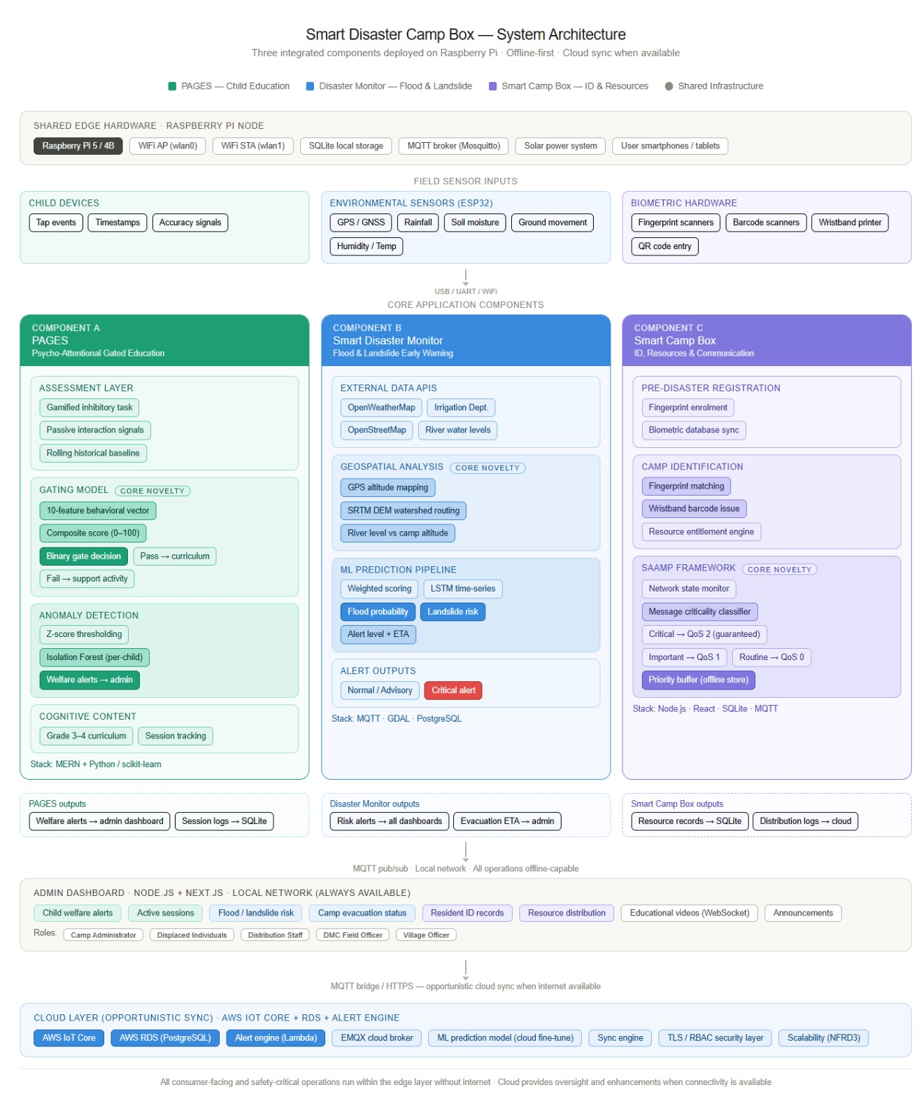

Image 1: Smart Disaster Camp Box System architecture

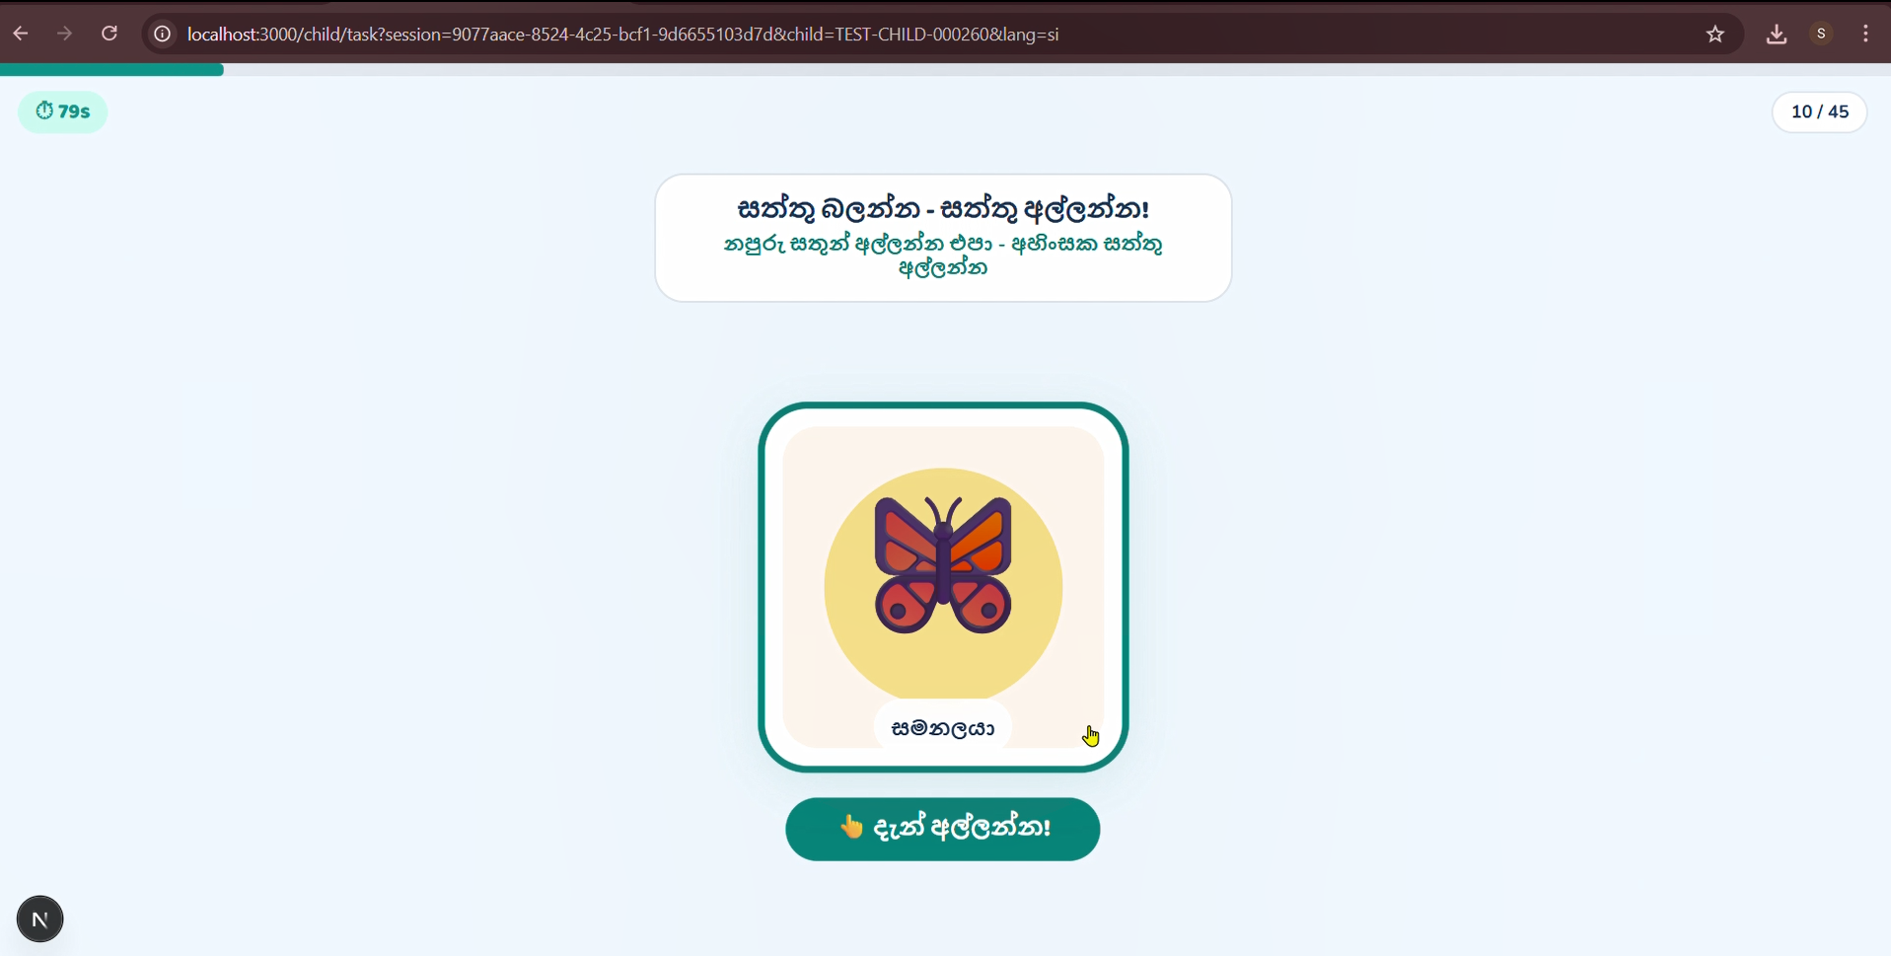
Image 2: Gamified Activity with a friendly animal

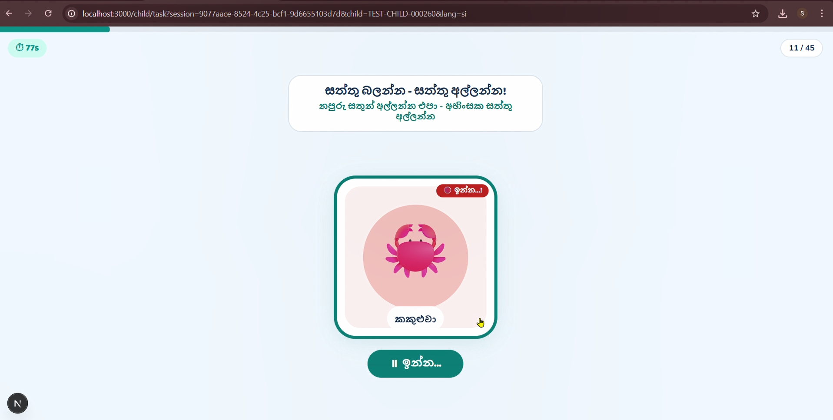
Image 3: Gamified Activity with an unfriendly animal

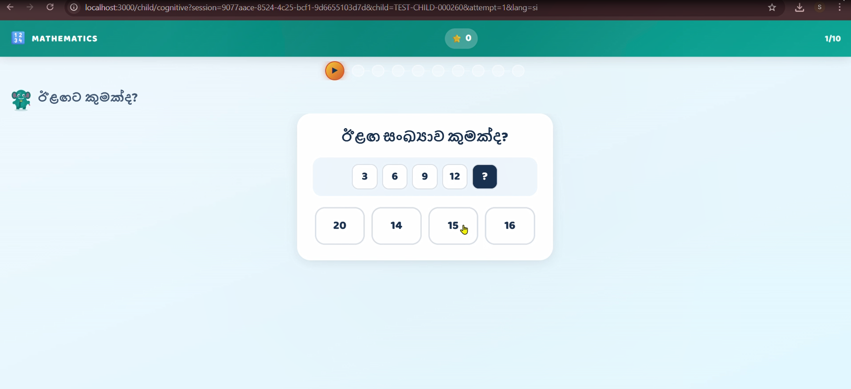
Image 4: Content session who passed from the gamified activity

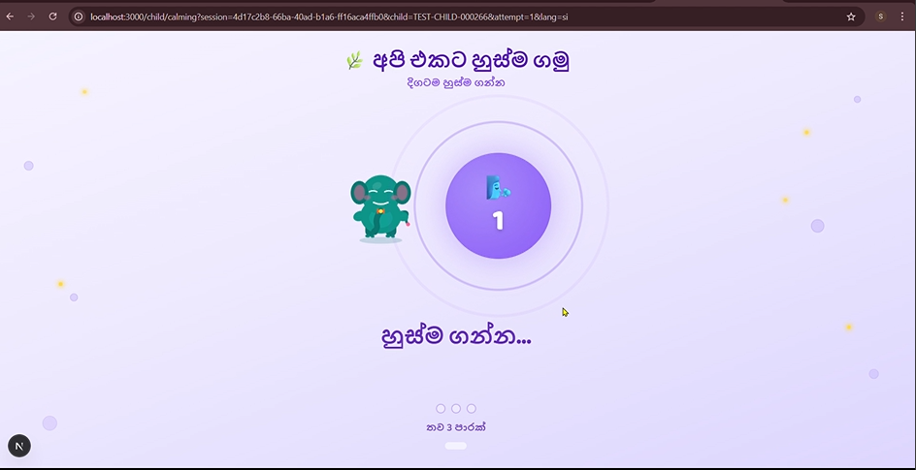
Image 5: Breathing Activity for those who failed the first attempt of the gamified activity

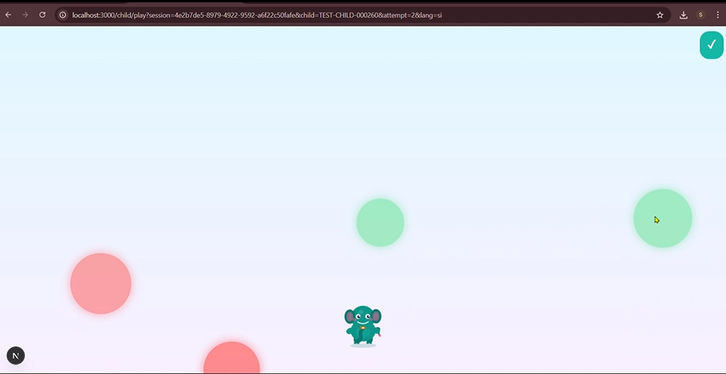

Image 6: If 2 attempts fail a simple game

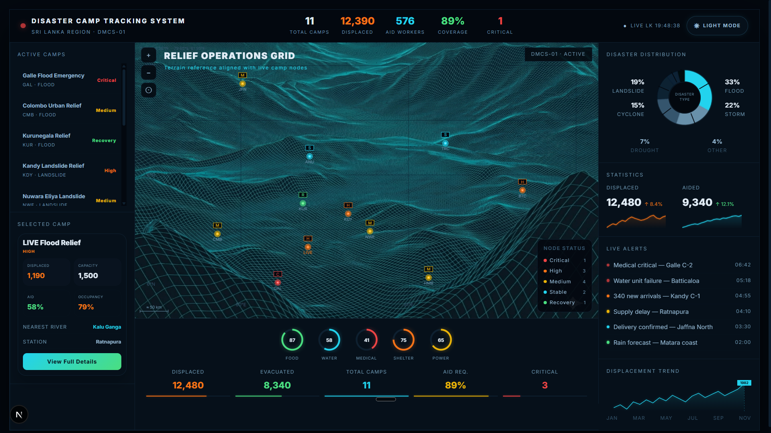Image 7: Dashboard page with each evacuation camp’s details

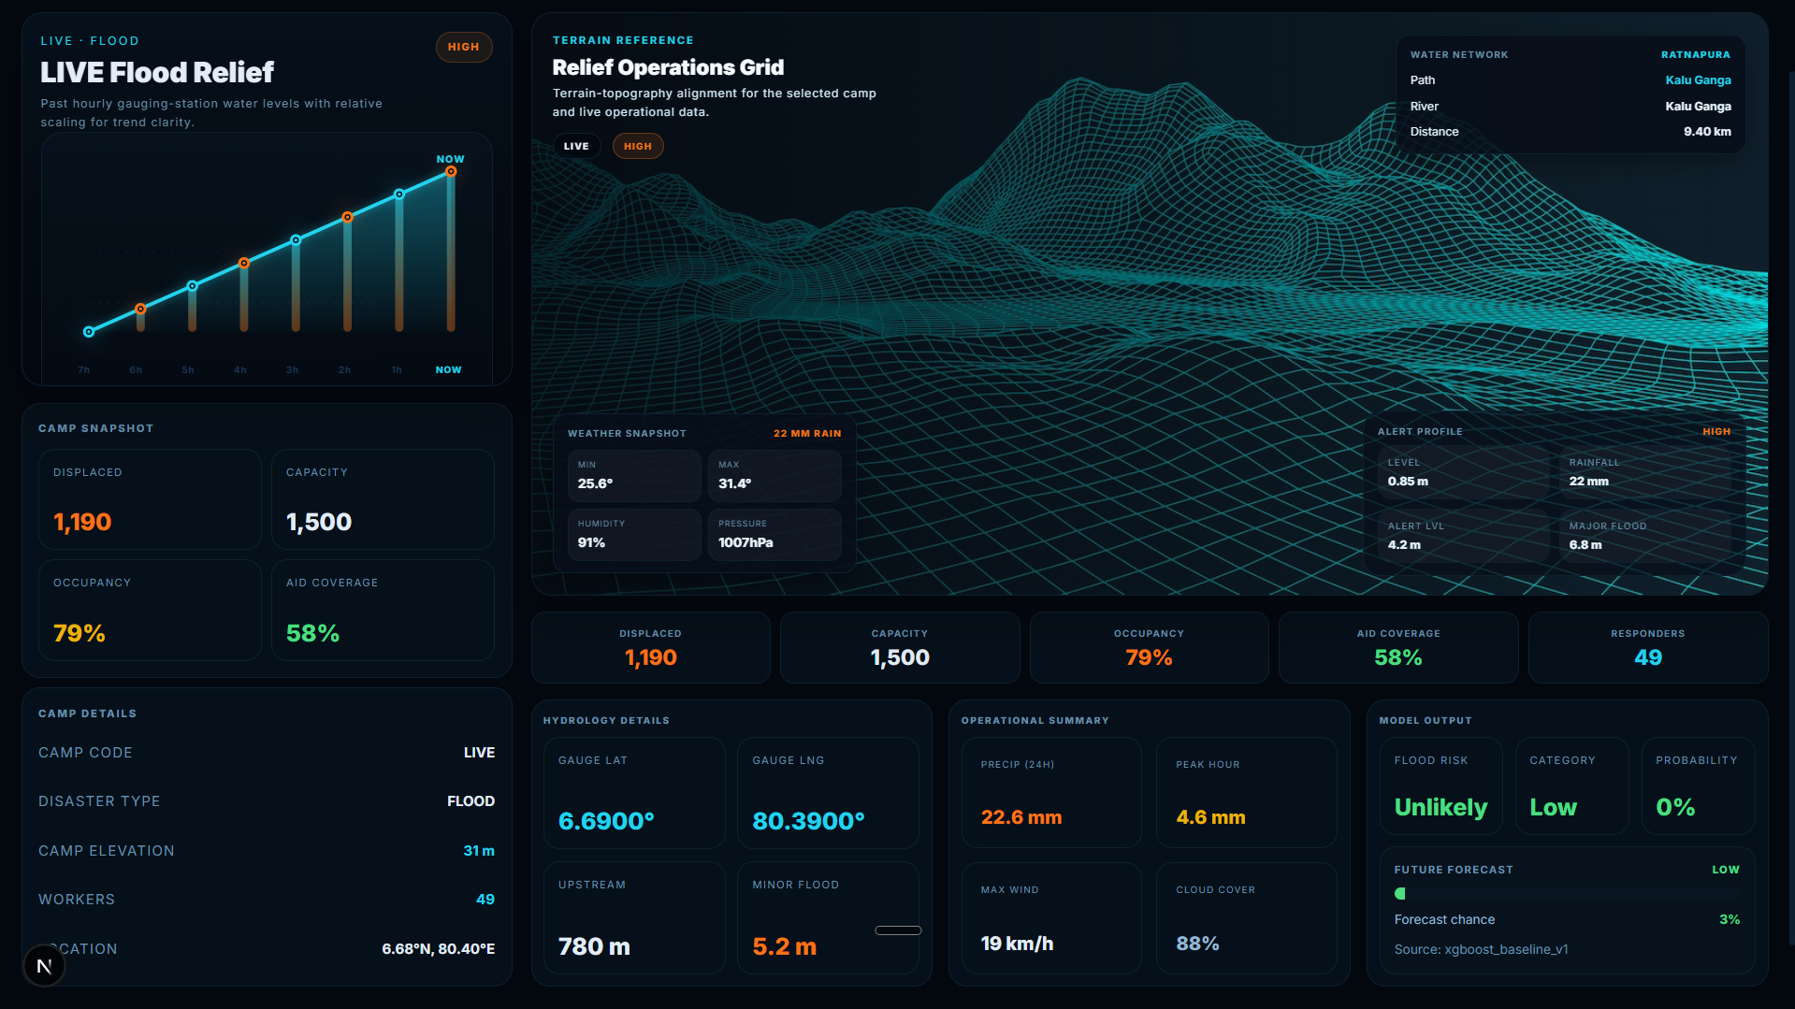Image 8: Selected evacuation camp details including all live details

Camp registration dashboard through fingerprint

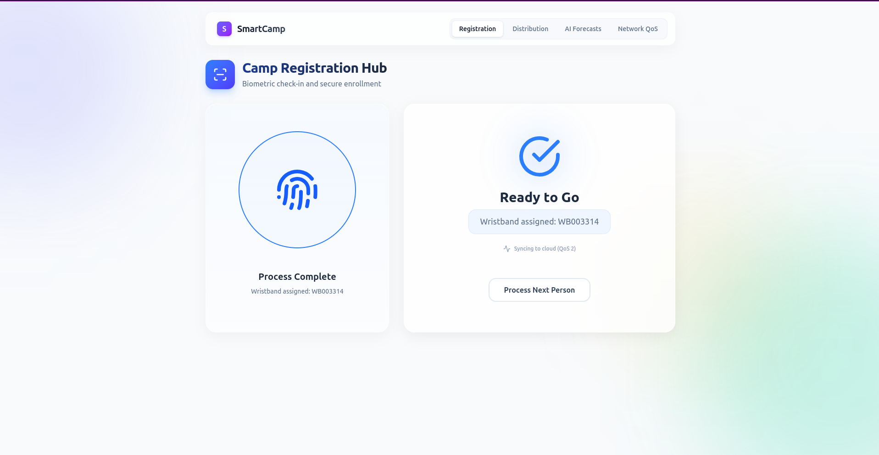
After registration system assign wristband allocated resources

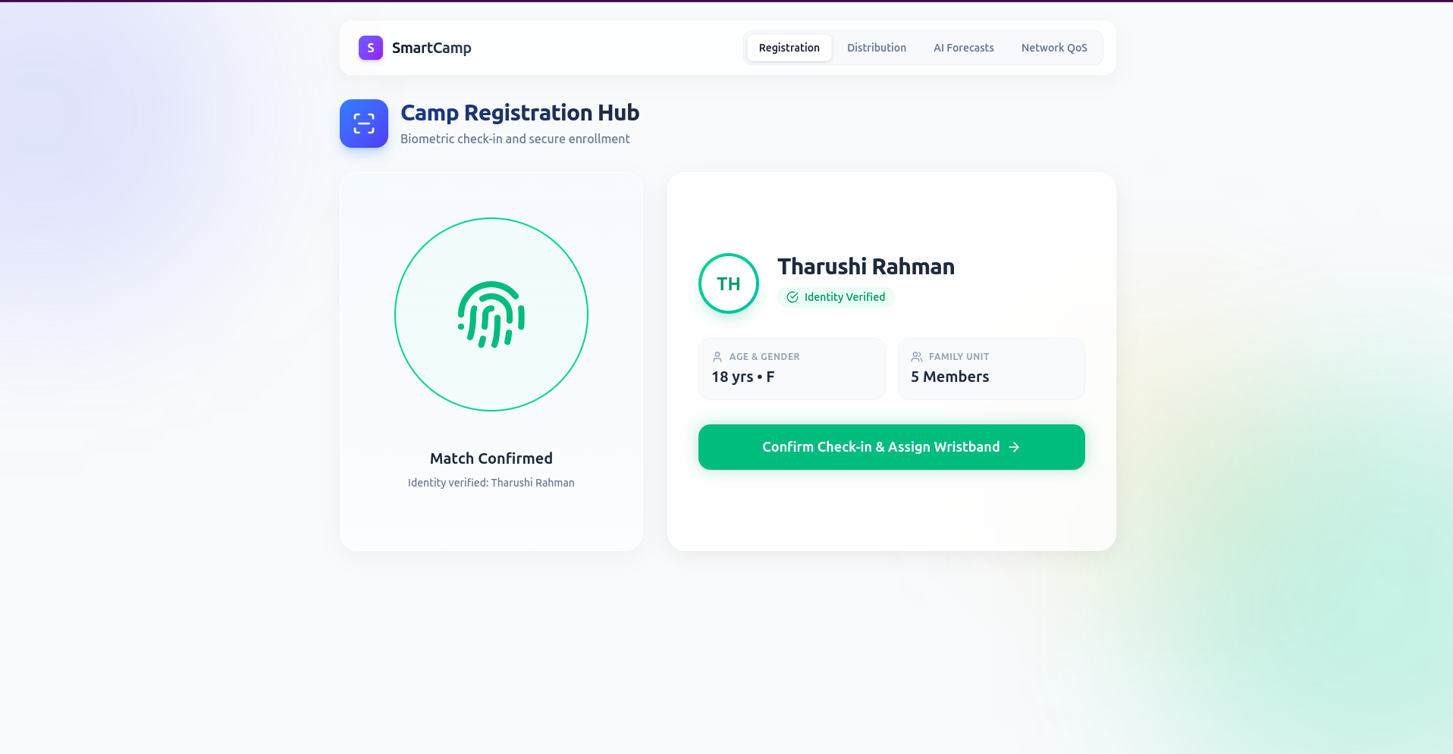

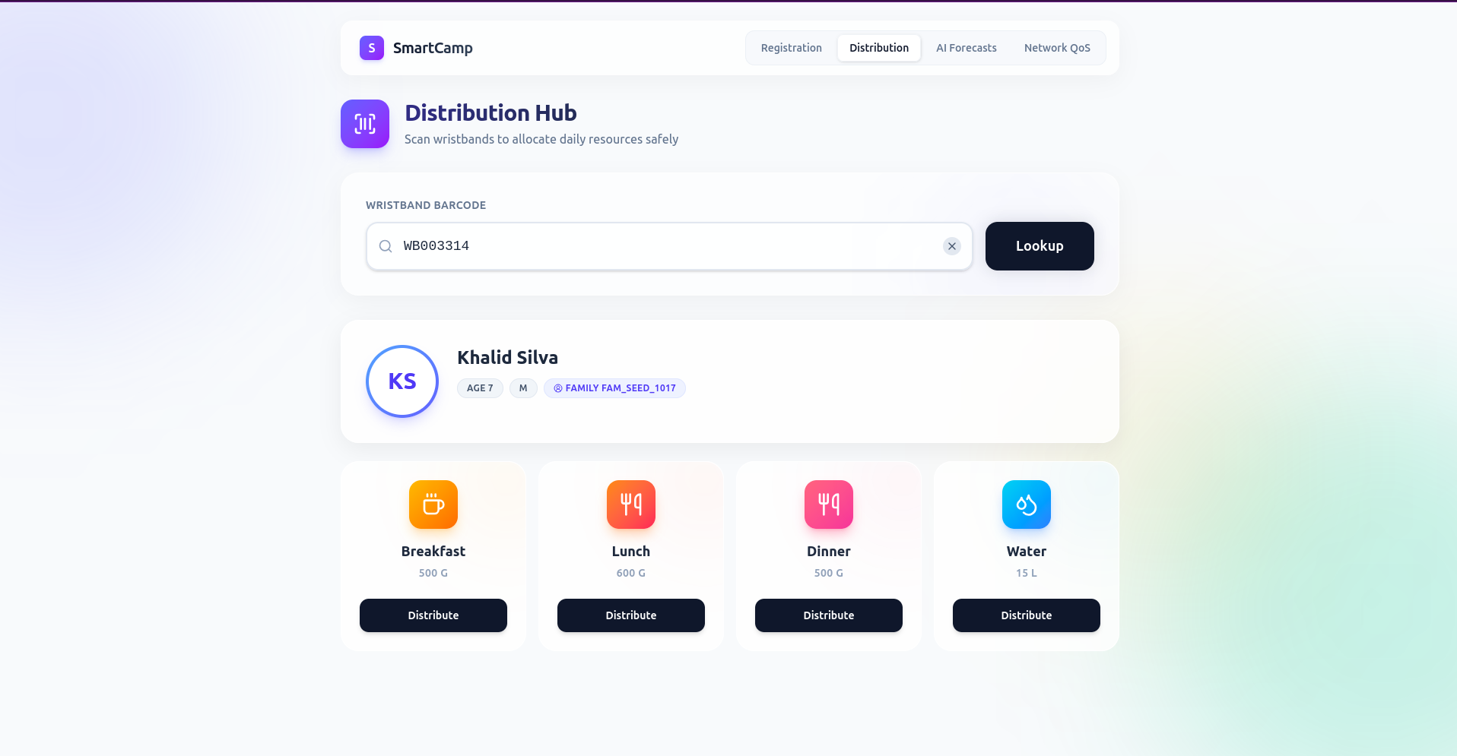

Semantic-Aware Adaptive Message Prioritization (SAAMP)

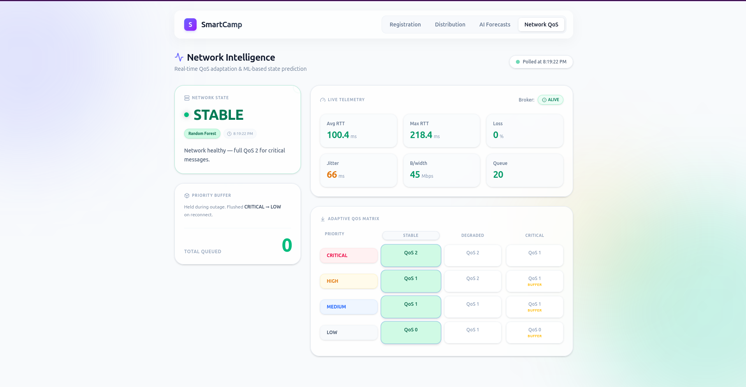
SAAMP Framework dashboard

